Question 2

1. To view the profit of a certain product, please press 1.

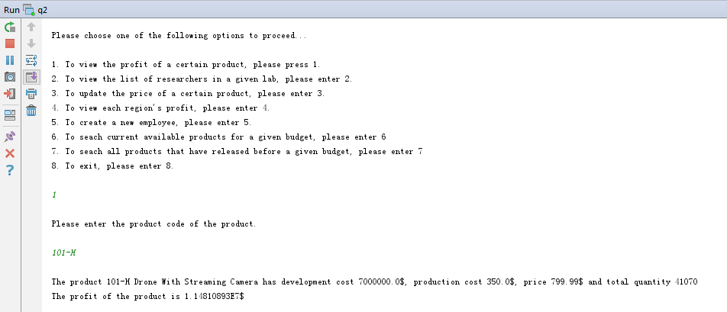

2. To view the list of researchers in a given lab, please enter 2.

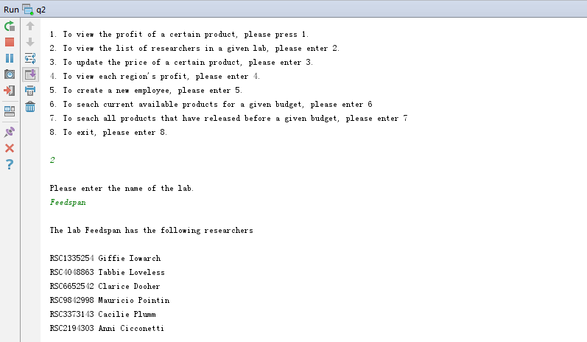

3. To update the price of a certain product, please enter 3.

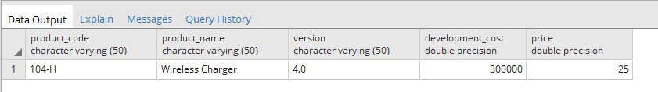

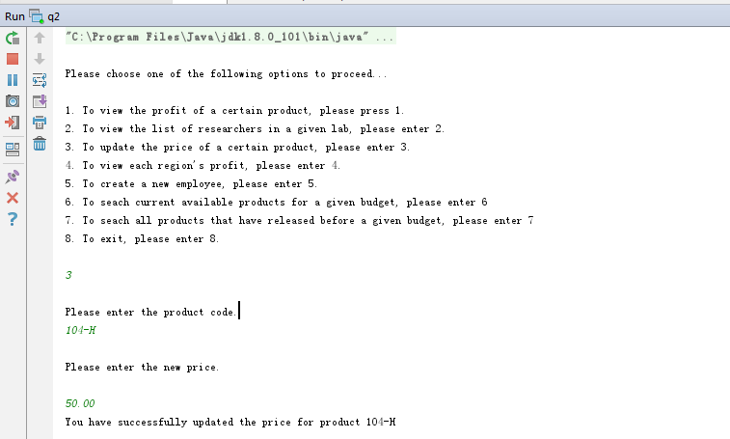

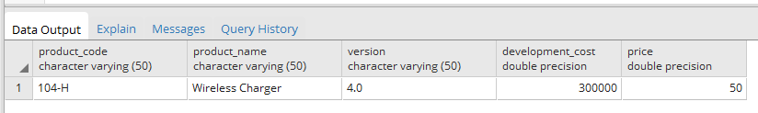

4. To view each region's profit, please enter 4.

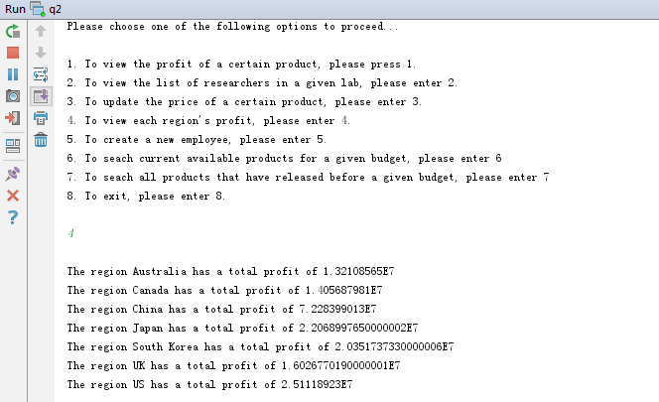

5. To create a new employee, please enter 5.

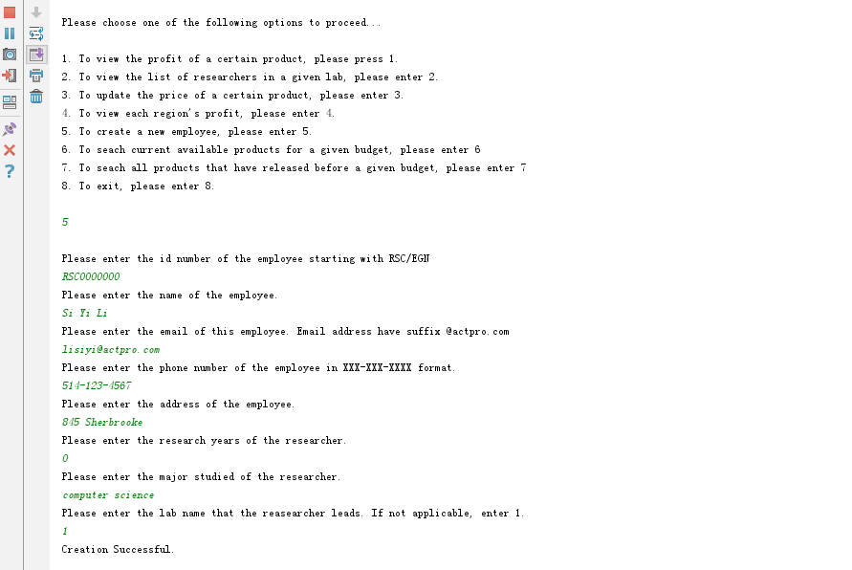



6. To seach current available products for a given budget, please enter 6

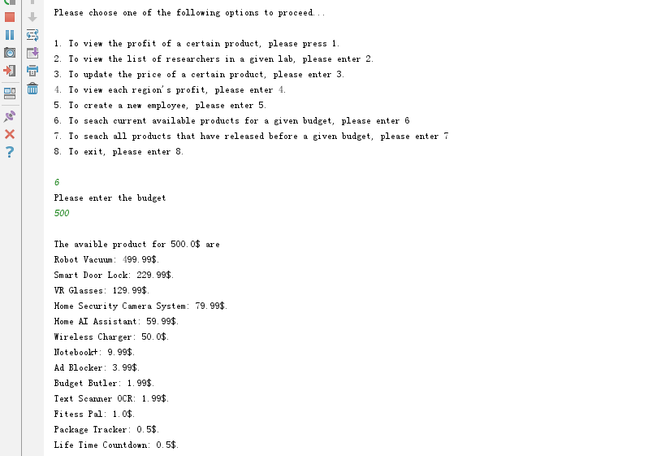

7. To seach all products that have released before a given budget, please enter 7

